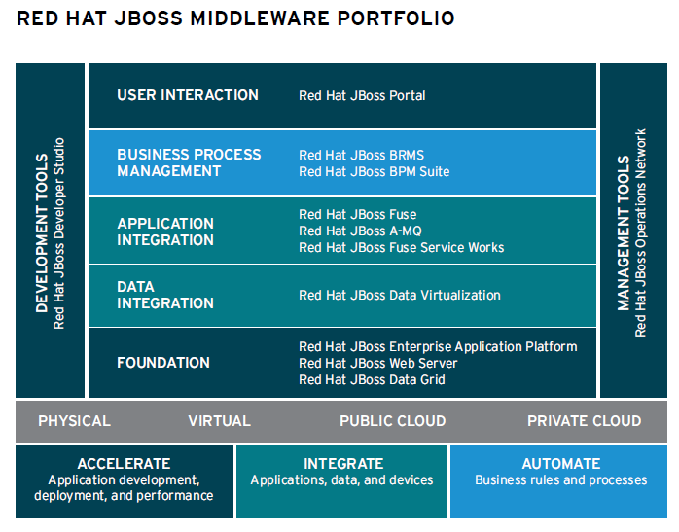

**Accelerate:**

* JBoss Enterprise Application Platform (EAP)
  + Keywords – Wildfly, Business Application, Application Deployment
  + Application Container to develop Apps fast and flexible on a java EE (J2EE) platform
  + Primary Competitors – WebLogic, WebSphere
  + How/how long does it take to develop your apps?
* JBoss Web Server
  + Keywords – Apache Tomcat, Apache HTTP (web server)
  + Delivers large scale websites and lightweight web apps
  + Primary Competitor – Free version
* JBoss Data Grid
  + Keywords – Cache, REST and HotRod
  + In-memory distributed databases designed for scalability and fast access to large volumes of data
  + Primary Competitors – WebSphere, Coherence, vFabric
* JBoss Developer Studio
  + Keywords – Enterprise JavaBeans, Maven, Hibernate
  + Provides superior support for your entire development lifecycle
  + Primary Competitor – Eclipse
* JBoss Operations Network (JON)
  + Keywords – Managed, Application Management
  + Single point of control to deploy, manage, and monitor your JBoss Enterprise Middleware, applications, and services
  + Primary Competitor – WebLogic/WebSphere Admin Consoles
* JBoss Portal
  + Keywords – Eclipse Portlet, GateIn, Web Interface
  + Lean portal for building high-impact, self-service applications
  + Primary Competitor – Portal Server

**Integrate:**

* JBoss Data Virtualization
  + Keywords – Hadoop, Consume/Compose/Connect
  + Lean, virtual data integration solution that unlocks trapped data and delivers it as easily consumable, unified, and actionable information
  + Primary Competitors – InfoSphere, Data Services, Oracle Virtualization
* JBoss A-MQ
  + Keywords – ActiveMQ, messaging, Karaf SW
  + Flexible, high-performance messaging platform that delivers information reliably, enabling real-time integration and the Internet of Things (IOT)
  + Primary Competitors – WebSphere MQ, Pivotal RabbitMQ
* JBoss Fuse
  + Keywords – Camel, Enterprise Service Bus (ESB)
  + Flexible, small-footprint enterprise service bus (ESB) that enables rapid integration across the extended enterprise
  + Primary Competitors – Mule ESB, IBM Integration Bus, Oracle Service Bus
* JBoss Fuse Service Works
  + Keywords – Switchyard, Overlord, SOA Platform
  + A platform that creates reusable, changeable, and flexible business services that hide the complexity of connecting to different applications
  + Primary Competitors – IBM Integration Bus, Oracle SOA Suite

**Automate:**

* JBoss BRMS
  + Keywords – Drools, Business Rules Management
  + Comprehensive platform for business rules management and complex event processing
  + Primary Competitors – FICO Blaze Advisor, WebSphere Operational Decision Manager, Progress Corticon
* JBoss BPM Suite
  + Keywords – jBPM, RiftSaw, Business Process Management
  + Comprehensive platform for business process management that can be deployed across physical, virtual, mobile, and cloud environments
  + Primary Competitors – WebSphere, Oracle BPM Suite, Pegasystems Process Commander